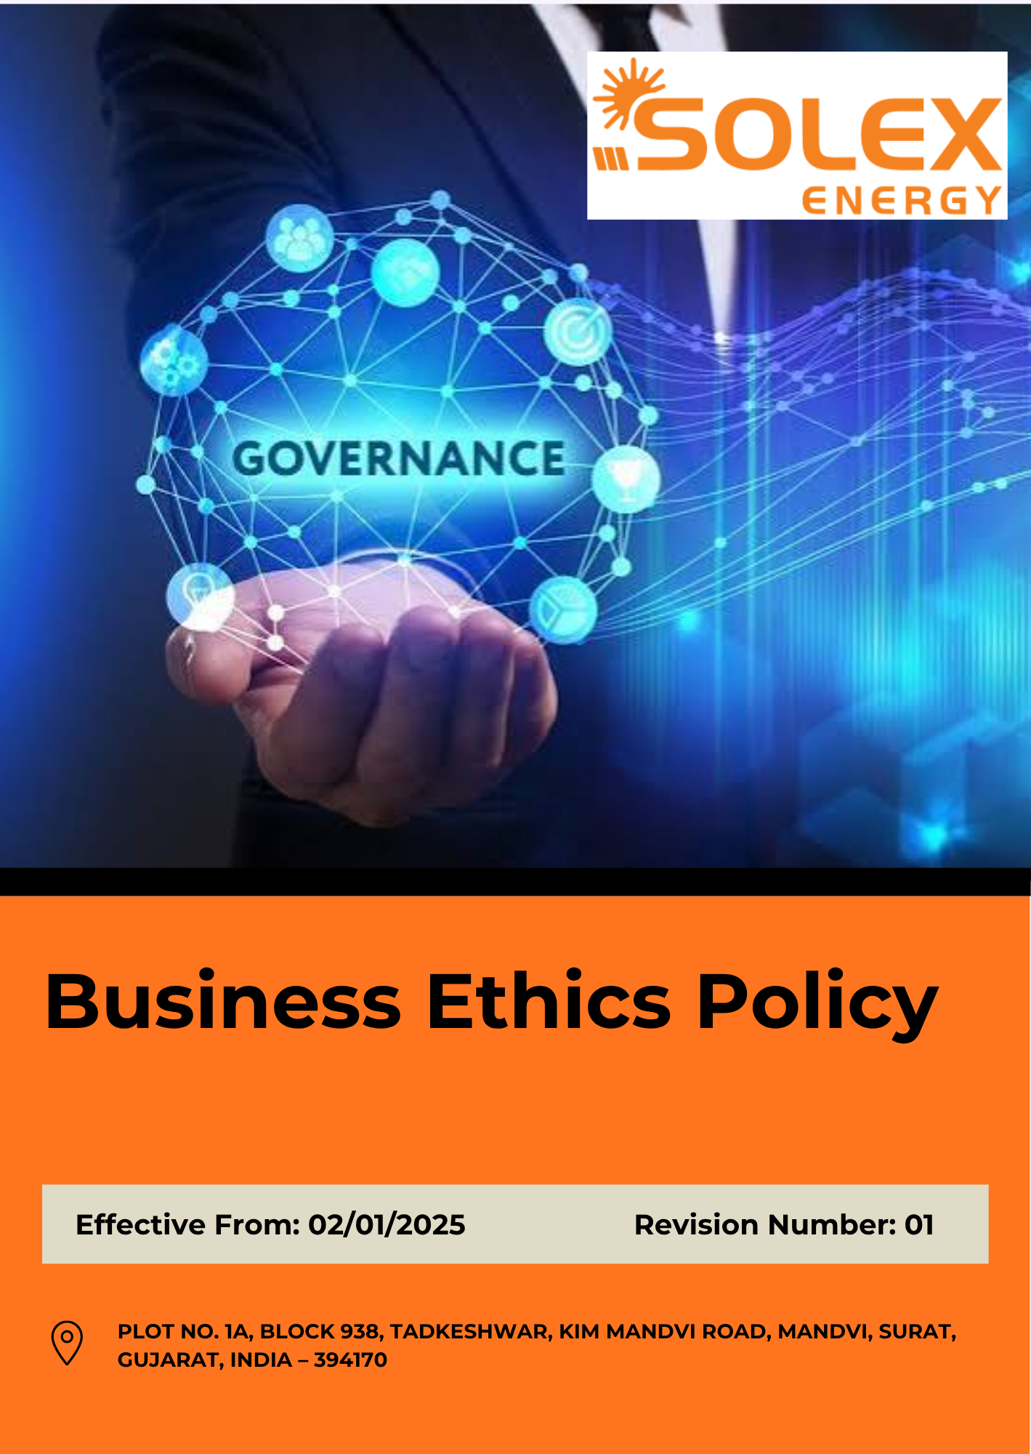
INDEX

1. Purpose & Policy Statement 3
2. Scope 3
3. Key Priority Areas – Business Ethics & Integrity 4
4. Our Strategic Goals and Commitments 4
5. Our Measurable Targets 7
6. Contribution to the Sustainable Development Goals (SDGs) 8
7. Expected Standards of Conduct 9
8. Governance 11
9. Reporting of Ethical Concerns 13
10. Reporting on Ethics Performance 14
11. Accountability and Actions for Policy Breaches 15
12. Review Mechanism 16
13. Employee Acknowledgement 17

1. Purpose & Policy Statement
Solex Energy Limited is committed to conducting business with integrity, transparency, and accountability while complying with all applicable laws and regulations. The Company promotes high standards of corporate governance and ethical business conduct across its operations and business relationships.
The Company maintains zero tolerance for corruption, bribery, fraud, money laundering, conflicts of interest, and anti-competitive practices. Employees, contractors, suppliers, and business partners are expected to act honestly, fairly, and in accordance with applicable legal and ethical requirements.
Solex Energy Limited is also committed to the responsible management and protection of information. The Company shall safeguard confidential, personal, and business information and ensure its appropriate use, storage, sharing, and protection from unauthorized access or disclosure.
Through effective governance, internal controls, employee awareness, and reporting mechanisms, the Company aims to promote ethical behaviour, fair competition, information security, and a culture of accountability throughout its operations.

2. Scope
This Policy applies to all employees, directors, contractual workers, trainees, consultants, contractors, and other persons working on behalf of Solex Energy Limited. Where relevant, the principles of this Policy also extend to suppliers, service providers, business partners, and other third parties engaged with the Company.
The Policy covers governance-related matters across the Company's operations, including business ethics, anti-corruption, anti-bribery, fraud prevention, conflict of interest management, anti-money laundering, fair competition and antitrust compliance, responsible information management, data privacy, cybersecurity, regulatory compliance, whistleblower protection, and ethical conduct in business relationships.
Solex Energy Limited | Block No. 938, Plot No. 1A, Tadkeshwar, Taluka Mandvi, Kim–Mandvi Road, District Surat, Gujarat – 394170, India

3. Key Priority Areas – Business Ethics & Integrity
To uphold the highest standards of integrity, accountability, and responsible business conduct, Solex Energy Limited focuses on the following key priority areas:
- Anti-Bribery & Anti-Corruption: Strengthening measures to prevent, detect, and address bribery, corruption, facilitation payments, and other unethical practices across all business operations, projects, and stakeholder interactions.
- Conflict of Interest: Promoting transparent and unbiased decision-making by ensuring actual, potential, and perceived conflicts of interest are identified, disclosed, reviewed, and appropriately managed.
- Fraud Prevention: Enhancing systems and controls to prevent, detect, investigate, and mitigate fraud, financial misconduct, falsification of records, misappropriation of assets, and other dishonest activities.
- Anti-Money Laundering (AML): Maintaining strong financial integrity through appropriate due diligence, transaction monitoring, record-keeping, and controls designed to prevent money laundering, terrorist financing, and other financial crimes.
- Fair Competition: Conducting business in a fair, ethical, and lawful manner by promoting healthy competition, responsible market practices, and compliance with applicable competition and antitrust regulations.
- Information Security & Data Privacy: Protecting confidential, personal and business-critical information through effective cybersecurity measures, secure information management practices and compliance with applicable data privacy requirements.

4. Our Strategic Goals and Commitments
Solex Energy Limited has established key goals and commitments to strengthen corporate governance, promote ethical business conduct, ensure regulatory compliance, safeguard information assets, prevent corruption and misconduct, and support transparency, accountability, and continuous improvement across its operations and business relationships.
4.1 Anti-Bribery & Anti-Corruption
- Strengthen a culture of integrity, transparency and ethical conduct across all business activities and locations.
- Embed anti-bribery and anti-corruption principles into employee, contractor and business-partner engagement processes.
- Strengthen awareness and understanding of bribery and corruption risks, particularly within functions exposed to higher compliance risks.
- Periodically review business activities and processes to identify, prevent and address potential bribery and corruption risks.
- Maintain effective mechanisms for reporting, investigating and addressing suspected bribery, corruption or unethical conduct without retaliation.

4.2 Conflict of Interest
- Promote transparency and impartiality in business decisions by strengthening the management of actual, potential and perceived conflicts of interest.
- Integrate conflict-of-interest requirements into employee onboarding, periodic declarations and relevant business processes.
- Strengthen awareness among employees and management regarding identification, disclosure and appropriate management of conflicts of interest.
- Ensure disclosed conflicts are reviewed objectively and managed through appropriate mitigation and approval mechanisms.
- Periodically review conflict-of-interest controls to identify emerging risks and improve governance practices.

4.3 Fraud Prevention
- Strengthen a culture of accountability and zero tolerance towards fraud, financial misconduct and deliberate misrepresentation.
- Integrate fraud-risk considerations into relevant financial, operational, procurement and business processes.
- Strengthen preventive and detective controls to identify unusual transactions, activities and potential fraudulent behaviour.
- Promote awareness among employees regarding fraud indicators, ethical responsibilities and available reporting channels.
- Periodically review fraud-prevention controls and implement corrective measures where control weaknesses or emerging risks are identified.

4.4 Anti-Money Laundering (AML)
- Strengthen controls to prevent Solex Energy Limited from being exposed to money laundering, terrorist financing and other illicit financial activities.
- Integrate appropriate customer, supplier and transaction due-diligence practices into relevant financial and commercial processes.
- Strengthen employee awareness of AML risks, red flags and escalation requirements applicable to their roles.
- Maintain transparent and traceable financial and commercial transactions supported by appropriate records and approvals.
- Periodically review AML-related controls and due-diligence practices to address emerging financial crime risks.

4.5 Fair Competition
- Promote fair, transparent and responsible competition in all sales, tendering, procurement and commercial activities.
- Strengthen employee understanding of competition-law principles and responsible market conduct.
- Ensure commercial decisions are based on legitimate business considerations and are free from improper coordination or anti-competitive practices.
- Integrate fair-competition principles into interactions with customers, competitors, suppliers and other business partners.
- Periodically review commercial practices to identify potential competition risks and strengthen controls where required.

4.6 Information Security & Data Privacy
- Strengthen the protection of confidential, personal and business-critical information throughout its lifecycle.
- Promote a culture of responsible information handling and cybersecurity awareness among employees and relevant third parties.
- Strengthen cybersecurity controls across corporate IT systems, manufacturing systems and other technology-enabled operations.
- Maintain effective processes for identifying, reporting, investigating and responding to information-security and data-privacy incidents.
- Periodically assess information-security and privacy risks and strengthen controls in response to identified vulnerabilities, emerging threats and changing business requirements.

5. Our Measurable Targets
Establishes 2023 as the Baseline year for measuring progress and achievements in our initiatives.
5.1 Anti-Bribery & Anti-Corruption
- Ensure 100% of employees and relevant contractors’ complete annual anti-bribery and anti-corruption training by Year 2030.
- Maintain zero (0) confirmed incidents of bribery or corruption tracked every financial year through Year 2030.
- Conduct an annual corruption risk assessment across all business functions and achieve 100% closure of resulting corrective actions by Year 2030.
- Ensure 100% of employees in high-risk functions (procurement, sales, EPC contracting, government liaison) complete enhanced anti-corruption training every year through Year 2030.

5.2 Conflict of Interest
- Ensure 100% of employees and contractors submit a Conflict-of-Interest declaration at onboarding and annually thereafter, through Year 2030.
- Review and close 100% of Conflict-of-Interest disclosures within 30 days of reporting, on an on-going basis through Year 2030.
- Conduct annual Conflict-of-Interest awareness training for senior management and other high-risk functions through Year 2030.

5.3 Fraud Prevention
- Conduct a fraud risk assessment at least once every two years through Year 2030.
- Achieve 100% completion of quarterly internal fraud-monitoring checks by Year 2030.
- Commission an independent or statutory fraud audit annually through Year 2030.
- Ensure 100% of employees are trained on fraud identification and reporting channels by Year 2030.

5.4 Anti-Money Laundering (AML)
- Ensure 100% of employees in finance, procurement, and export/sales functions complete AML compliance training annually through Year 2030.
- Conduct an annual AML audit of financial transactions and customer/supplier due-diligence records through Year 2030.

5.5 Fair Competition
- Ensure 100% of senior management, sales, and procurement teams are trained on competition-law compliance by Year 2030.
- Conduct an annual self-audit of tender, pricing, and vendor-selection practices, targeting zero (0) confirmed anti-competitive incidents through Year 2030.

5.6 Information Security & Data Privacy
- Maintain reported information-security incidents zero (0) through Year 2030.
- Conduct an annual cybersecurity risk assessment with 100% closure of identified gaps through Year 2030.
- Ensure 100% of employees complete annual information-security and data-privacy training through Year 2030.

6. Contribution to the Sustainable Development Goals (SDGs)
Through this Policy, Solex Energy Limited supports relevant SDGs by promoting integrity in business activities, strengthening governance and compliance practices, preventing corruption and misconduct, and encouraging responsible decision-making.
 |  | 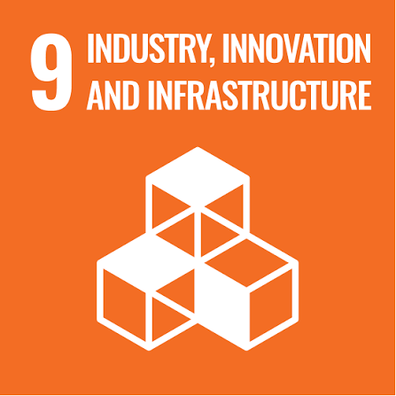 | 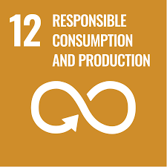

7. Expected Standards of Conduct
7.1 Anti-Bribery & Anti-Corruption
Do's
- Conduct business honestly, fairly, and transparently.
- Report any suspected bribery, corruption, or unethical conduct.
- Follow approved authorization and approval processes for payments and transactions.
- Maintain accurate records of gifts, hospitality, donations, and business expenditures.
Don'ts
- Offer, promise, give, request, or accept bribes or kickbacks.
- Make facilitation payments to obtain improper business advantages.
- Conceal suspicious transactions or unethical conduct.
- Use third parties to engage in corrupt practices on behalf of the Company.
7.2 Conflict of Interest
Do's
- Disclose actual, potential, or perceived conflicts of interest promptly.
- Act in the best interests of the Company when making business decisions.
- Seek guidance when uncertain about a potential conflict.
- Update conflict-of-interest declarations when circumstances change.
Don'ts
- Allow personal interests to influence business decisions.
- Participate in decisions where a conflict exists without disclosure and approval.
- Use Company resources or information for personal benefit.
- Conceal relationships that may create a conflict of interest.

7.3 Fraud Prevention
Do's
- Maintain accurate and complete business records.
- Report suspected fraud, misconduct, or irregular activities.
- Follow established financial and operational controls.
- Cooperate with investigations and audits.
Don'ts
- Falsify documents, records, or reports.
- Misappropriate Company assets, funds, or resources.
- Manipulate financial information or performance data.
- Engage in deceptive, dishonest, or fraudulent activities.
7.4 Anti-Money Laundering (AML)
Do's
- Conduct appropriate due diligence on customers, suppliers, and business partners.
- Verify and maintain accurate transaction records.
- Report suspicious financial transactions through designated channels.
- Follow applicable AML compliance procedures.
Don'ts
- Participate in transactions intended to conceal the source of funds.
- Process transactions without appropriate documentation or approvals.
- Ignore suspicious financial activities or red flags.
- Engage with individuals or entities involved in illegal financial activities.
7.5 Fair Competition
Do's
- Compete fairly and ethically in the marketplace.
- Make independent business and pricing decisions.
- Follow applicable competition and antitrust laws.
- Maintain professional interactions with competitors and industry participants.
Don'ts
- Engage in price-fixing, bid-rigging, or market-sharing arrangements.
- Exchange sensitive commercial information with competitors.
- Abuse market position or engage in unfair trade practices.
- Participate in anti-competitive agreements or discussions.
7.6 Information Security & Data Privacy
Do's
- Protect confidential, personal, and business-critical information.
- Use Company information systems responsibly and securely.
- Follow cybersecurity and data privacy requirements.
- Report information-security incidents or suspected breaches promptly.
Don'ts
- Share confidential information without authorization.
- Access information that is not required for your role.
- Use unauthorized software, devices, or storage systems for Company data.
- Ignore cybersecurity alerts, vulnerabilities, or security incidents.

8. Governance
Board of Directors
Provides overall oversight of business ethics, corporate governance, compliance, integrity, and ethical-risk management, and reviews the Company's performance through the established governance, compliance, and risk-management framework.
Senior Management
Provides leadership, resources, and accountability for the implementation of this Policy and ensures that business ethics, compliance, integrity, risk management, and responsible business conduct considerations are integrated into business planning, operational activities, and decision-making processes.

Compliance Officer
Acts as the custodian of the Company's Business Ethics Policy and supports compliance with applicable laws, regulations, governance requirements, and internal policies. Compliance Officer coordinates ethics and compliance activities, conflict-of-interest management, regulatory monitoring, awareness programmes, reporting mechanisms, and periodic policy reviews. The Policy shall be reviewed and updated annually & whenever there are changes in applicable laws, regulations, Company procedures, business operations, or identified ethics and compliance risks.
Chief Finance Officer
Supports the implementation of financial controls designed to prevent fraud, corruption, money laundering, financial misconduct, and unauthorized transactions. Maintains appropriate records and supports
Information Technology Manager
Supports the implementation of information security, cybersecurity, and data privacy controls to protect confidential, personal, and business-critical information. Monitors information-security risks and supports incident response and corrective actions.
Department Heads & Supervisors
Promote ethical conduct within their areas of responsibility, support awareness and compliance activities, encourage reporting of concerns, and ensure adherence to applicable business ethics requirements.
Employees and Contractors
Comply with applicable Company policies, procedures, and legal requirements; participate in required training; disclose conflicts of interest; protect Company information; and promptly report suspected misconduct, fraud, corruption, information-security incidents, or other compliance concerns.
Suppliers and Business Partners
Are expected to comply with applicable contractual obligations and relevant business ethics, integrity, compliance, information-security, and responsible business conduct requirements established by Solex Energy Limited.
The effectiveness of awareness and compliance programmes shall be periodically evaluated through assessments, audits, compliance reviews, reporting trends, investigations, performance indicators, and other appropriate monitoring mechanisms.

9. Reporting of Ethical Concerns
Employees, contractors, suppliers, customers, and other stakeholders are encouraged to report any suspected or actual violation of this Policy, applicable laws, regulations, or ethical business conduct requirements.
Concerns may be raised regarding, but are not limited to:
- Bribery, corruption, or improper payments
- Fraud, financial misconduct, or falsification of records
- Conflicts of interest
- Money laundering or suspicious financial transactions
- Anti-competitive or unfair business practices
- Information security or data privacy breaches
- Violations of Company policies, legal requirements, or ethical standards
- Retaliation against individuals reporting concerns in good faith
Concerns may be reported through the Company's designated reporting channels, including immediate supervisors, department heads, Human Resources, the Compliance Officer, senior management, or whistleblower mechanism established by the Company.
All concerns shall be reviewed appropriately and, where necessary, investigated in a fair, objective, and timely manner. Solex Energy Limited prohibits retaliation against any individual who raises a concern or reports suspected misconduct in good faith.
Ethics Reporting Contact: ethics@solex.in
Whistleblower/Compliance Contact: [Insert designated email/contact details]
(Use actual contact details before finalizing the policy.)

10. Reporting on Ethics Performance
Transparent and regular reporting is essential for monitoring the effectiveness of Solex Energy Limited’s business ethics policy, ensuring accountability, and supporting continuous improvement. Solex Energy Limited shall implement the following reporting practices:
- Business Ethics Performance Reporting: Solex Energy Limited shall periodically review and report its performance against established business ethics and integrity objectives, targets, and key performance indicators. The reporting shall cover relevant areas including ethics and compliance training, anti-bribery and anti-corruption measures, reported concerns, investigations, confirmed violations, corrective actions, conflicts of interest, information security breaches and compliance with applicable laws and internal requirements.
- Internal Reviews and Audits: Solex shall conduct periodic internal reviews and audits, as applicable, to assess compliance with this Policy and related procedures. Audit and review findings shall be documented, communicated to the relevant management personnel, and followed by appropriate corrective and preventive actions.
- Ethics Concern and Incident Reporting: Solex Energy Limited shall maintain appropriate records of ethics-related concerns, complaints, suspected misconduct, investigations, and confirmed violations received through designated reporting channels. Significant or material matters shall be escalated to the appropriate level of management for review and necessary action.
- Management Reporting: Business ethics performance, significant incidents, compliance risks, investigation outcomes, and the status of corrective actions shall be periodically reported to senior management and relevant governance bodies, as applicable. Management shall review such information to assess the effectiveness of existing controls and determine areas requiring further action.
- Stakeholder Feedback: Solex Energy Limited shall consider relevant feedback and concerns received from employees, contractors, suppliers, customers, and other stakeholders regarding ethical business conduct. Where appropriate, such feedback shall be considered in strengthening controls, addressing identified risks, and improving the Company’s ethics and compliance practices.
- Public Disclosure: Solex Energy Limited may disclose relevant information regarding its business ethics and integrity performance through its annual report, sustainability or ESG disclosures, website, or other approved communication channels. Such disclosures shall be made in accordance with applicable disclosure requirements while protecting confidential, personal, and commercially sensitive information.

11. Accountability and Actions for Policy Breaches
Compliance with this Business Ethics Policy is mandatory for all employees and relevant business partners of Solex Energy Limited. Any violation shall be taken seriously and may result in appropriate disciplinary or contractual action based on the nature, severity, and intent of the misconduct.
For employees, actions may include counselling, verbal or written warnings, suspension, or termination of employment. Employees in managerial or leadership positions may be subject to enhanced accountability, including removal from their position or termination of services.
Where misconduct involves suspected or confirmed illegal activities, including fraud, bribery, or corruption, the matter may be reported to the relevant regulatory or law enforcement authorities in accordance with applicable laws.
For vendors, suppliers, contractors, or other business partners, violations may result in corrective action, suspension or termination of the business relationship, recovery of losses, or disqualification from future engagement.
Solex Energy Limited may also implement corrective measures, including additional training, process improvements, or enhanced controls, to prevent recurrence. All actions shall be taken fairly and consistently, with appropriate opportunity for the concerned party to provide an explanation through the established review mechanism.

12. Review Mechanism
Compliance Officer shall review this Business Ethics Policy annually to ensure its continued relevance and effectiveness. The review shall consider ethics performance, compliance requirements, audit findings, reported concerns, and stakeholder feedback.
The Policy shall be updated as required to reflect changes in applicable laws, regulations, Company procedures, business operations, or identified ethics and compliance risks. Significant updates shall be communicated to relevant employees and stakeholders.
Revision History
Revision No. | Date | Description of Change
0.0 | 02/01/2025 | Initial release of Business Ethics Policy
1.0 | 02/01/2026 | Addition of the Expected Standards of Conduct along with a review and update of measurable targets and strengthening of the review mechanism.

Approved by:

[Name]
Chairman & Managing Director
Solex Energy Limited

13. Employee Acknowledgement
I acknowledge that I have received, read, and understood the Business Ethics Policy of Solex Energy Limited. I understand that the Policy establishes the Company’s expectations regarding ethical conduct, integrity, compliance with applicable laws, prevention of bribery and corruption, responsible business practices, and reporting of concerns.
I understand that compliance with this Policy is mandatory and that I am responsible for conducting my work in accordance with its requirements and for raising any suspected violation or ethical concern through the designated reporting channels.
I understand that violations of the Policy may result in appropriate corrective or disciplinary action in accordance with Company procedures and applicable laws. I also acknowledge that the Policy is reviewed annually and may be updated when required.
By signing below, I confirm my understanding of and commitment to comply with the Business Ethics Policy.
Employee Name | ______________________________
Employee ID / Department | ______________________________
Acknowledgement Date | ______________________________
Employee Signature | ______________________________

